Brittany Chiang
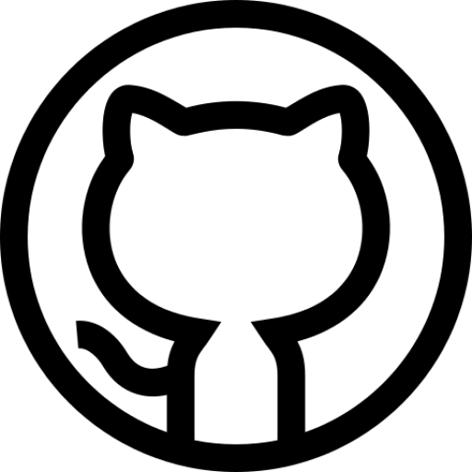


Front-End Software Engineer


brittany.chiang@gmail.com
914-960-3665
brittanychiang.com
github.com/bchiang7

Relevant Experience

Engineer @ Upstatement
May 2018 - Present // Boston, MA
▹ Write modern, performant, and robust code for a diverse array of client and internal projects
▹ Work with a variety of different languages, frameworks, and content management systems
such as JavaScript, TypeScript, React, Vue, NativeScript, Node.js, Craft, Prismic, etc.
▹ Communicate and collaborate with multi-disciplinary teams of engineers, designers, producers, clients, and stakeholders on a daily basis

Studio Developer @ Scout
Jan - April 2018 // Boston, MA
▹ Worked with a team of three designers to build a marketing website and e-commerce platform for blistabloc, an ambitious venture originating from Northeastern
▹ Helped solidify a brand direction for blistabloc to span across print, packaging, and web
▹ Interfaced with clients on a weekly basis, providing technological expertise and knowledge

UI Engineer Co-op @ Apple
July - Dec 2017 // Cupertino, CA
▹ Developed and shipped highly interactive web applications for Apple Music using Ember
▹ Built and shipped the Apple Music Extension within Facebook Messenger leveraging third-
party and internal APIs
▹ Architected and implemented the front-end of Apple Music's embeddable web player widget, which lets users log in and listen to full songs in the browser
▹ Contributed extensively to MusicKit.js, a JavaScript framework that allows developers to add
an Apple Music player to their web apps

Studio Developer @ Scout
Jan - June 2017 // Boston, MA
▹ Collaborated with a small team of student designers to spearhead a new brand and design system for Scout’s inaugural student-led design conference at Northeastern
▹ Worked closely with designers and management team to develop, document, and manage the conference’s marketing website using Jekyll, Sass, and JavaScript

Software Engineer Co-op @ Starry
July - Dec 2016 // Boston, MA
▹ Engineered and maintained major features of Starry's customer-facing web app using ES6, Handlebars, Backbone, Marionette, and CSS
▹ Proposed and implemented scalable solutions to issues identified with cloud services and applications responsible for communicating with Starry Station
▹ Interfaced with user experience designers and other developers to ensure thoughtful and
coherent user experiences across Starry’s iOS and Android mobile apps

Creative Technologist Co-op @ MullenLowe U.S.
July - Dec 2015 // Boston, MA
▹ Developed and maintained code for in-house and client websites primarily using HTML, CSS, Sass, JavaScript, and jQuery
▹ Tested sites in various browsers and devices to ensure cross-browser compatibility and mobile responsiveness
▹ Clients included JetBlue, Lovesac, U.S. Cellular, U.S. Department of Defense, and more

Skills
Programming Languages JavaScript (ES6), TypeScript, HTML, CSS/Sass, GraphQL, Python, R, PHP

Libraries & Frameworks
jQuery, React, Gatsby, Vue, Node.js, Express, Jekyll, Timber, NativeScript

Tools & Platforms
Git, Gulp, Webpack, Netlify, Heroku, Prismic, Contentful, Craft, Wordpress, Docker, Firebase

Design
Sketch, InVision, InDesign

Education

Northeastern University
2013 - 2018 // Boston, MA
Bachelor of Science in Information Science Human Computer Interaction Concentration Minors in Interaction & Experience Design

Study Abroad
Summer 2016 // Budapest, Hungary
Experience Design of Travel Dialogue

Projects

Spotify Profile
Web app built with React, Node.js, and Express for visualizing personalized Spotify data such as top artists, tracks, recommendations, and audio features

Halcyon Theme
Minimal, dark blue theme for VS Code, Sublime Text, Atom, and more published to Visual Studio Marketplace, Package Control, Atom Package Manager, and NPM

Interests
Snowboarding, swimming, traveling, reading, hiking

